Project Design Phase-II Data Flow Diagram



Yes

No

|  |  |
| --- | --- |
| Date | 30 October 2022 |
| Team ID | **PNT2022TMID03180** |

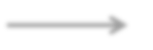

Start

Checking Threshold

Sensor send the values to the Arduino board

Getting value from sensor



Database

The sense data goes to the Network and the status of the water module



Send SMS to Mobile

Send the report to the Authorities



Stop